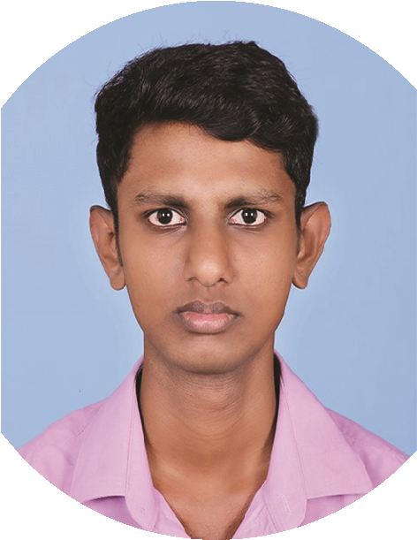
•Currently Folowing HDSE program in IJSE

OTHER QUALIFICATION

jew
INTRESTS
• Cerficate Course in Computer Studies (Level 2)
(Schooner Computer Academy, Galle Sri Lanka)
• Cerficate Course in Computer Studies (Level 1)
(Schooner Computer Academy, Galle Sri Lanka)
• Member,prefect board(2016-2018)

• Volunteering and Parcipang in Social Actvies events

• Group Hiking Tours

• Volunteering at local companies, clubs and organizaons
• Organizing events in the community
PERSONAL
INFORMATION
EDUCATION

OBJECTIVES
Name :
A.D.D. Tharusha
Address :
/2, Makurugoda Road,
25
Puhulduwa, Baddegama.
Date of Birth :
2001/04/17
Phone No & email :
070-3645490 dineshtharusha@gmail.com
Language :
Sinhala, English
NIC No :
200110800036
School Atended :
G/ Vidyaloka College
Gender :
Male
Civil Status :
Single
Naonality :
Sri Lankan
A. D
DINESH THARUSHA

• I passed the G.C.E. O/L Examinaon in 2007
• I passed the G.C.E. A/L Examinaon in 2021

Buddhism

A
A

Sinhala

History
A

A
Mathemacs

English
A

Science
A

Health & Phy.
A
Commerce

B

C
Music

Eager to learn and ready to work hard to achieve customer satisfaction through the utilization of my dynamic, warm, and accommodating personality, along with strong communication and leadership skills gained as a student committee member

Subject

Grade
Mathemacs

C
C
Chemistry

S

Physics

English
Bdcdcdc

cd

Subject

Grade
PERSONAL

..........................................
Date
...........................................
Applicant Signature

I hereby solemnly declare that the information furnished above is true, correct, and complete to the best of my knowledge and belief. I understand that any false statement may lead to rejection of my application.

.
JOB EXPEREINCE
SKILLS
Gold Loan Officer
(Union Bank finance Galle & Amalangoda branch),
(2022-2024)
• Update customer records in the company database as required
• Input invoice and bill-back data
• Analyze, consolidate, and forward daily report summaries to
manager
• Use data to organize marketing campaign

• Achieve monthly/quarterly sales targets for gold loan business (volume and value) generating leads and acquiring new customers.

• Support renewal and closure of loans, including release of gold after full repayment

• Evaluate and assess the purity, weight, and market value of gold ornaments/jewelry brought by customers using standard tools and methods.

• Maintain customer database by inputing customer profile and
updates
• Collect data to create informative sales presentations
• Process and verify gold loan applications, including customer KYC, documentation, and eligibility check

I work as a Video Editor at Digivis Creaon

(2020-2022)
• Good Communicaon and good Interpersonal skills
• Problem Solving
• Basic I.C.T Knowledge
• Ability to work with team and ability to work alone
• Whenever necessary. Friendliness and Passivity
• Leadership

